**Scrum**

Scrum is a management and control process that cuts through complexity to focus on building products that meet business needs. Management and teams are able to get their hands around the requirements and technologies, never let go, and deliver working products, incrementally and empirically.

Scrum is simple.  It is the opposite of a big collection of interwoven mandatory components. Scrum is not a methodology. Scrum implements the scientific method of empiricism. Scrum replaces a programmed algorithmic approach with a heuristic one, with respect for people and self-organization to deal with unpredictability and solving complex problems.

* A product owner creates a prioritized wish list called a product backlog.
* During sprint planning, the team pulls a small chunk from the top of that wish list, a sprint backlog, and decides how to implement those pieces.
* The team has a certain amount of time — a sprint (usually two to four weeks) — to complete its work, but it meets each day to assess its progress (daily Scrum).
* Along the way, the ScrumMaster keeps the team focused on its goal.
* At the end of the sprint, the work should be potentially shippable: ready to hand to a customer, put on a store shelf, or show to a stakeholder.
* The sprint ends with a sprint review and retrospective.
* As the next sprint begins, the team chooses another chunk of the product backlog and begins working again.

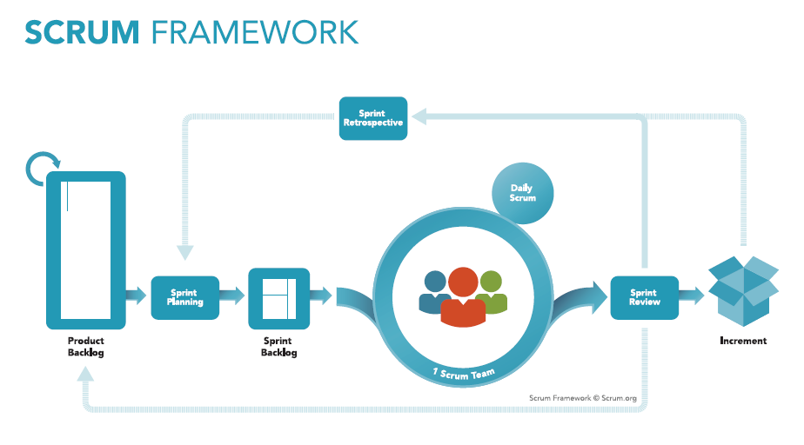

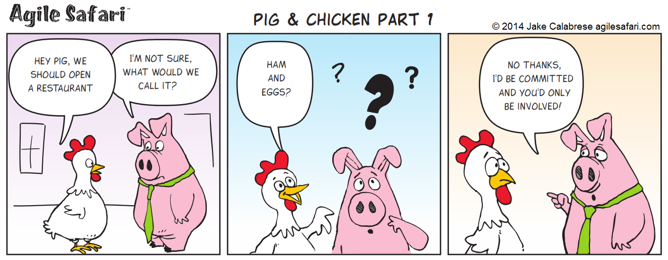

This cartoon illustrates two potential business partners, the chicken and the pig.  They want to start a restaurant together called Ham n Eggs.  The pig however is not convinced since he would have to be fully committed to the idea, providing himself as the main course, while the chicken only has to just participate with it’s eggs.

Scrum participants fall into the same two categories.  They are either Pigs or they are chickens.  Participants at scrum are either fully committed to the project or simply participants.  Let’s look at who these various roles really are.

**Pig Roles**

Actual Team Members.  These would be the developers, artists or product managers that comprise the core of the team.  These are the people who are actually doing the daily work to bring the project to fruition.  These members are fully committed to the project.

Scrum Master.  The scrum master might be one of the team members — or might not be.  It is important to call this person out separately here though because the Scrum master has the primary role of ensuring that the scrum moves forward without problems and is effective for the team.

Project Owner.  This may be a Product Manager who is also comprised of the team or it may not.  Again it is important to call this persons role out here as this person represents the voice of the end customer.  This person needs to ensure that the product achieves it’s product goals and provides the necessary end product to the customers.

**Chicken Roles**

Managers.  At first glance you might think that managers are pigs — naturally.  However in the scrum context managers are generally more concerned about the people involved in a project and their respective health.  They are not as focused on the product and it’s particular customer oriented goals.  For this reason they are considered a chicken in the scrum context.

Stakeholders.  Stakeholders are individuals who will benefit or have a vested interest in the project, however do not necessarily have authority to dictate direction or to be held accountable for the product.  They can be consulted for opinions and insight however the product owner needs to maintain final rights for the decision making process.

**Why are the roles important**

The chicken and pig roles are vital to scrum because it dictates who in the scrum should be an active participant   Chickens should not be active participants in a scrum meeting.  They may attend, however they should be there as guests only and not required to share their current statuses.  Pigs on the other hand need to share their current progress and share any blockers that they are encountering.

The reason that Chickens should not be active participants is that they too easily will take over the direction of the scrum and lead it away from the goals of the entire team.  it is the scrum masters job to ensure that the scrum stays on target and covers the topics that need to be covered.  if someone goes off topic (chicken or pig) it is the scrum masters job to bring the group back to the topic at hand.

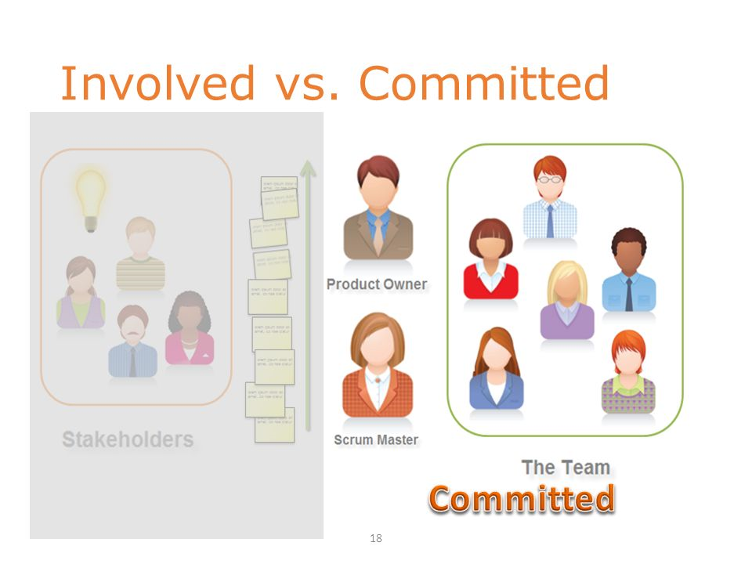

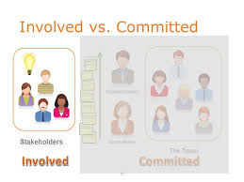

**Team and Roles in Scrum**

**Product Owner**

The product owner is the cornerstone of project success, responsible for defining the work that needs to be completed and prioritizing that work. He or she needs to know what the project is expected to deliver and *why* those elements are important -- to customers, to the market, to the organization. The product owner must also be the face of all of those interests to the project team, acting as an expert guide as the team carries out the project.  
  
An important difference between the product owner and any nominally similar role in traditional project execution is that the product owner remains actively involved throughout. For example, the product owner reviews and reprioritizes outstanding work based on shifting needs and ongoing feedback. That contrasts with a traditional sponsor, who defines all of the work up front in the scope statement. By extension, the product owner is also responsible for communicating and explaining those changing priorities and their impacts to the project team.  
  
The product owner is the hub of business value for Scrum initiatives; his or her entire focus is on ensuring that the work actually done aligns with the work that needs to be done to meet the project objectives. This may create the temptation for product owners to try to control the work, but that is not part of their role (we'll explore that more when we get to the development team). A product owner must be highly self-disciplined to avoid trying to manage the development team's activities. He or she is assisted in that by the ScrumMaster.

Day to day activities of a Product Owner

1. Creates and MAINTAINS the Product Backlog. I emphasize MAINTAINS as this is an on-going job and more than likely a full-time activity. Nothing is constant in the world of software and it’s important that the Product Owner keeps his/her eye on the ball. Note: the Product Backlog must be groomed prior to the Sprint Planning Meeting in order for the team to remain productive.

2. Prioritizes and sequences the Backlog according to business value or ROI (there are lots of tools to help Product Owners do this and lots of books on the subject) The Product Owner is required to have the Backlog sequenced prior to the Sprint Planning Meeting. This means that each user story must be ordered by relative importance. It’s no good to have 5 high priority or 5 medium priorities. It’s important to know which User story is #1, which is #2 etc.

3. Assists with the elaboration of Epics, Themes and Features into user stories that are granular enough to be achieved in a single sprint. User Stories are elaborated at the last responsible moment and it is the Product Owners responsibility to be there during the Sprint Planning meeting to help the teams to understand exactly what is required.

4. Conveys the Vision and Goals at the beginning of every Release and Sprint. The Product Owner must continuously remind the Team of the Sprint and Release goals. This helps to keep the team on track and serves as an over-arching yardstick for the team to measure their activity and progress against.

5. Represents the customer, interfaces and engages the customer. The Product Owner must continuously engage the customer and stakeholders to ensure the Team is building the right product and therefore delivering the ROI expected of it. The Product Owner has the opportunity to steer the team in a different direction at the end of every Sprint, so he/she must be ready to do just that if necessary.

6. Participates in the daily Scrums, Sprint Planning Meetings and Sprint Reviews and Retrospectives. There’s always a lot going on and always an excuse to miss the meetings. But each of these Scrum ceremonies is another chance for the Product Owner to inspect and adapt. And as a result being present at these ceremonies is tantamount to success.

7. Inspects the product progress at the end of every Sprint and has complete authority to accept or reject work done. Work that is either not complete or un-done needs to be re-prioritized or sequenced. An Agile PM is one who is quick to recognize and understand change and to ensure the Product Team adapts to the change in landscape, be it competition, target market or other.

8. Can change the course of the project at the end of every Sprint (30 days if you’re following traditional Scrum methodology by the book). The Product Owner is in complete control and can steer the team in a completely different direction at Sprint boundaries. And good Agile teams will welcome this change as long as the Product Owner is confident and knowledgeable.

9. Communicates status externally. The product owner is the voice of the Team to the outside world and should ensure that all channels of communications are open and that projects have the right amount of support required to succeed.

10. Terminates a Sprint if it is determined that a drastic change in direction is requirede.g. a competitor releases a new version which demands a counter response. This is a pretty serious event for Scrum teams. And what this means “technically” is that all work done up until that point is lost. I have not seen this done to many times in my career especially since, there’s really not that much time between Sprints in any event.

**The Product Owner is the captain of the ship, while the Scrum Master is the First Lieutenant; one decides on the mission, the other works with the crew to ensure proper and efficient execution of the necessary tasks to accomplish the mission.**

**Scrum Master**

The ScrumMaster role has two distinct elements. First, he or she acts as the protector of the team, making sure that everyone on the project, especially the development team members, can focus on their work without any distractions. Some of those distractions may be directly associated with the work -- the product owner who oversteps the boundaries, for example, and starts to dictate the work approach to the team. Or the ScrumMaster may need to protect the team from organizational disruptions or internal distractions -- arranging to replace problematic computers or providing a less noisy work area, for example.  
  
The second element of the ScrumMaster role is to protect the Scrum process itself. The ScrumMaster is the expert on how Scrum works and how it should be applied. He or she will ensure that the product owner and development team stay within the Scrum framework. By extension, the ScrumMaster can coach the other team members on how to use Scrum in the most effective manner.  
  
This is a very different role from that of a traditional project manager, despite frequent comparisons made between the two. Project managers are responsible for managing the work of project team members, and that guides their own day-to-day work. For the ScrumMaster, however, the only formal accountability is over the process.

Scrum Master is a Servant leader, does not command but empowers the team.

Day to day activities of a Scrum Master

1. Organizing the meetings (refinement sessions, daily standup, sprint review, retrospective, sprint planning)  
   - because the sprint rythm is known, this can be planned way ahead  
   so it takes some time one time, and very little after that
2. Facilitating the team members solving impediments  
   - avoiding the pitfall to resolve the impediment yourself  
   - the team should be self-organizing / self-managing as much as possible  
   - the Scrum Master should do as little as possible
3. Facilitating the Product Owner in fulfilling his role adequately  
   In many organizations this is quite a challenge  
   Because often the PO role is assigned to people who don’t have experience with it, who have very little time for it and who often don’t get training
4. Facilitate preparing and having the meetings  
   - the sprint review can often be done by team and PO  
   - the refinement meetings depend on the maturity of the team  
   - the sprint planning can often be done by the team  
   - the restrospective often needs good preparation and guidance  
    to keep it inspiring and instructive
5. Facilitate the team in following the Scrum process  
   - often discipline is quite a challenge for teams  
    e.g. moving the cards / tickets the moment they are ready / start working on something new  
   - this is a combination of asking questions and making remarks during the  
    different meetings and sometimes having a one-on-one with one of the team members to discuss a specific aspect or behaviour

**Scrum Team/Team Members**

The Team is responsible for turning the product backlog items into incrementsof valuein each Sprint. It consists of a cross functionalteam of 7 +- 2 people. There might be core team members and shared team members. They are self organising and collaborating. The team also contains generalized specialists where one team member can help in more than one task. They deliver value in small chinks in sprints. They are committed. They are focussed on customer and Build in quality.

The Scrum team consists of BA’s, Developers, Tech Architects, Data Analysts/Data Modelers, Testers, etc. The scrum team basically consists of IT atheletes who basically can take the project and run. That said, the roles specifically point to how the deliverable can be acieved together rather than individually.